Solution for Activity 5 – Adding Image file paths to the database

The solution to this activity is

1. You will have run the SQL given, using your name and retrieved your member ID value, mine was 2



Figure 3.61 SQL to extract the user ID of a member by surname

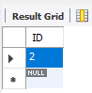

Figure 3.62 ID for user Pettit

1. Add a photo of yourself to the Members/Photos folder, your member ID should be in the name



Figure 3.63 Fred and I?

1. You will have created a script in a new SQL tab to update your record with the image and path and executed it to get the below results.

UPDATE `members`

SET

PhotoPath = "Members\\Photos\\MemberPhoto_2.jpg"

WHERE `ID`=2;

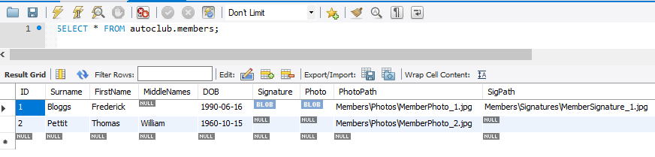

Figure 3.64 Results with member 2 showing the image path

1. You will have created an SQL script to that below to get the results, also shown below

SELECT CONCAT((SELECT `Value` FROM `lookups` WHERE `Key`="ImageRepository") , `PhotoPath`) AS FullPhotoPath

FROM `members` WHERE `members`.`ID`=2



Figure 3.65 Full file path for the image